**Flightfinder: Navigating your air travel options**

|  |  |  |  |  |
| --- | --- | --- | --- | --- |
| **Domain** | **Name** | **Team ID** | **Roll No** | **College** |
| FULLSTACK | K A V Sri Vyshnavi | LTVIP2025TMID54499 | 22Pa1A5729 | VISHNU INSTITUTE OF TECHNOLOGY |
| FULLSTACK | Gundu Lakshmi Deepika | LTVIP2025TMID54499 | 22PA1A0554 | VISHNU INSTITUTE OF TECHNOLOGY |
| FULLSTACK | K Sai Rohith | LTVIP2025TMID54499 | 22Pa1A1285 | VISHNU INSTITUTE OF TECHNOLOGY |
| FULLSTACK | Kallam Renuka Devi | LTVIP2025TMID54499 | 22PA1A1262 | VISHNU INSTITUTE OF TECHNOLOGY |

**Introduction:**

Welcome to Flight Finder, your one-stop destination for finding, booking, and managing flights seamlessly. Designed with a clean interface and modern functionality, Flight Finder simplifies air travel booking by offering a fast, reliable, and user-friendly platform. From searching flights to managing bookings, our app brings the entire experience to your fingertips.

**Description:**

Flight Finder is a full-stack web application designed to streamline the flight booking process for users, operators, and admins. Key features include:

* 🛫 **Flight Search** – Search by source, destination, and date
* 🧳 **Booking Flights** – Add multiple passengers and calculate total cost
* 🔐 **Authentication** – Secure login/register with JWT
* 🛠️ **Admin Dashboard** – Manage flights, users, and revenue
* 🧑‍✈️ **Operator Approval** – Admin can approve/reject operators
* 👤 **User Roles** – Role-based access for users, admins, and operators
* 📆 **Booking Management** – Users can cancel/view bookings
* 📊 **Flight CRUD** – Add, edit, delete flights
* 🔍 **Live Search Results** – See matching flights on homepage

Built using the **MERN Stack** (MongoDB, Express.js, React.js, Node.js), Flight Finder ensures a dynamic and responsive user experience with robust backend support.

**Tech Stack:**

* **Frontend:** React.js, Bootstrap, Axios
* **Backend:** Node.js, Express.js
* **Database:** MongoDB Atlas
* **Authentication:** JWT (JSON Web Token)

**Functional Modules:**

**1. User Authentication:**

* Registration and login for users with JWT-based session management.
* Role-based access control for user, operator, and admin.

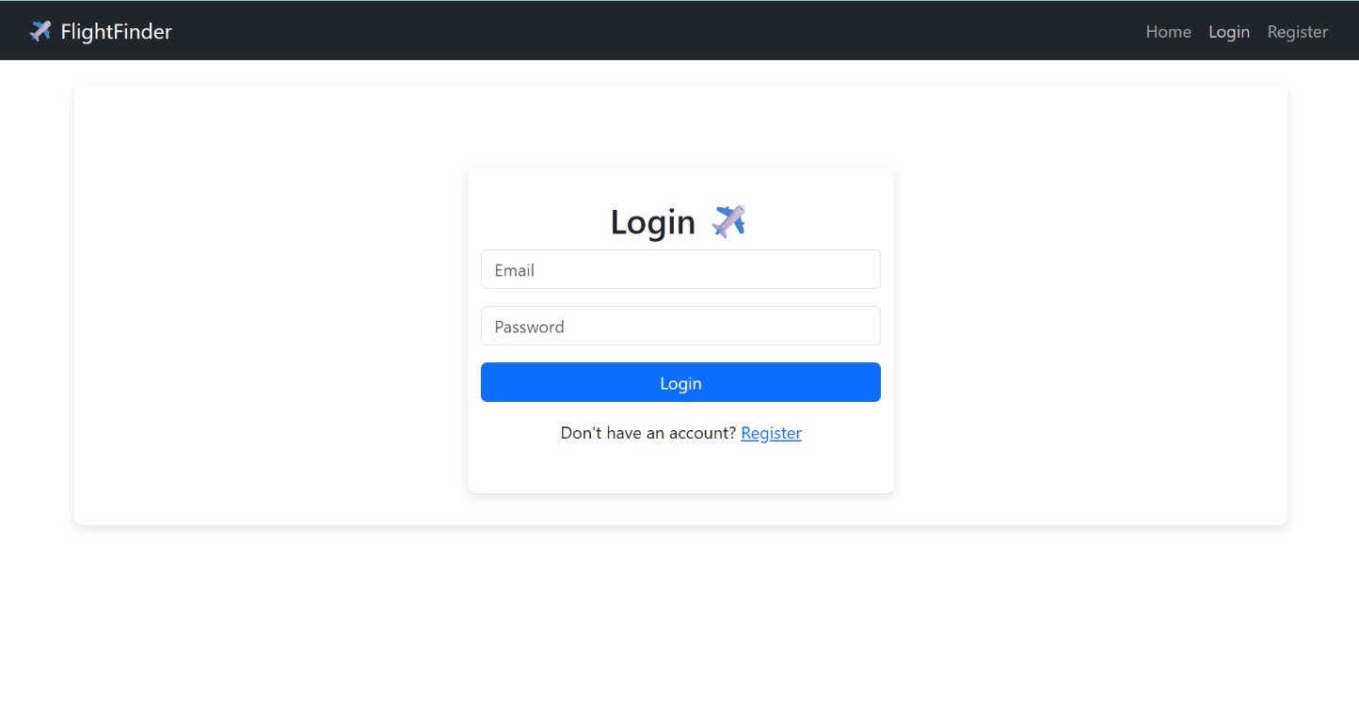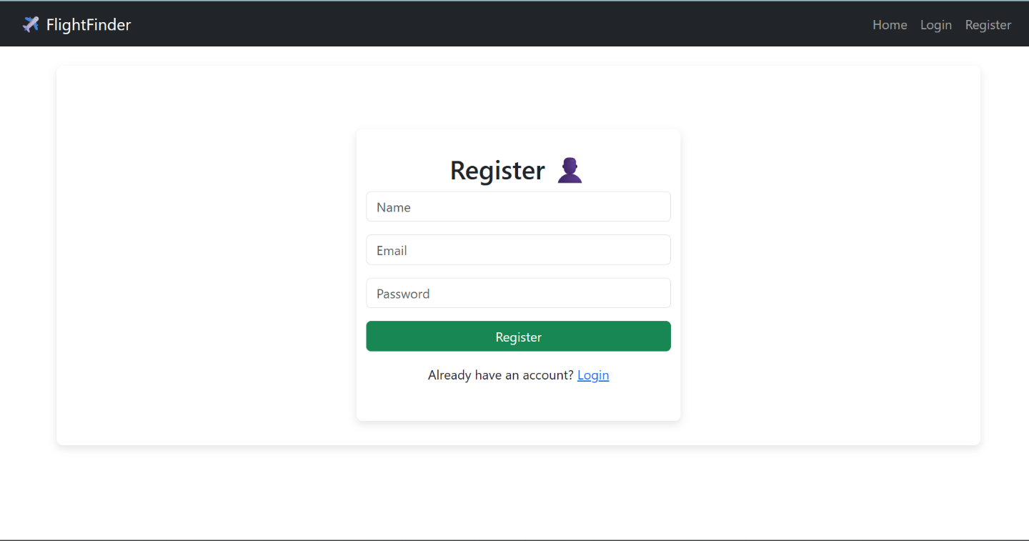

**2. Home Page:**

* Hero section with welcome message and search form.
* About Us section to describe the platform.

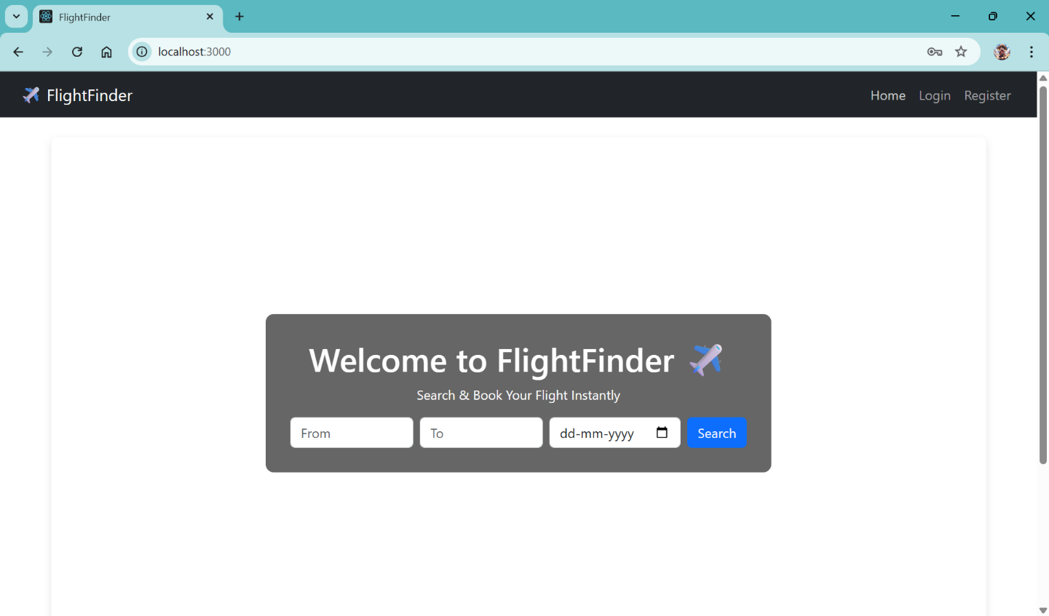

**3. Flight Search:**

* Search Bar component filters flights based on source, destination, and date.
* Search results are displayed dynamically without reloading the page.

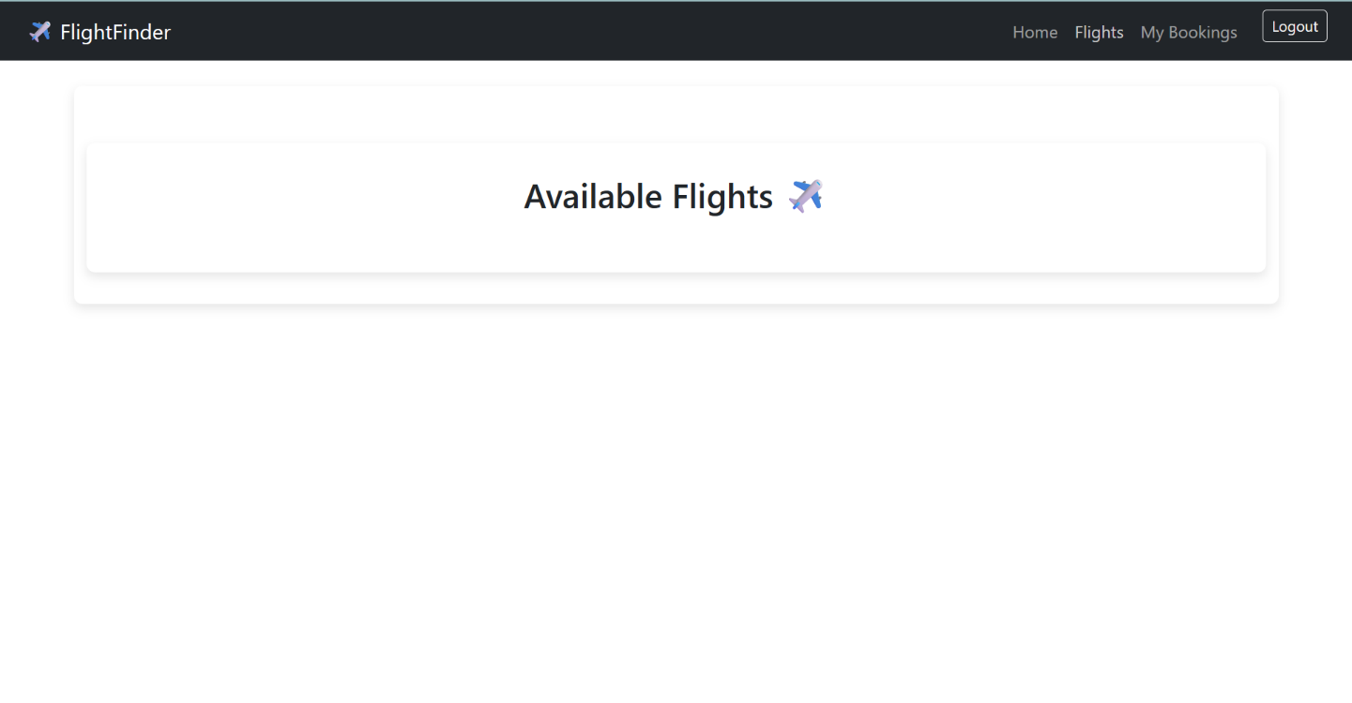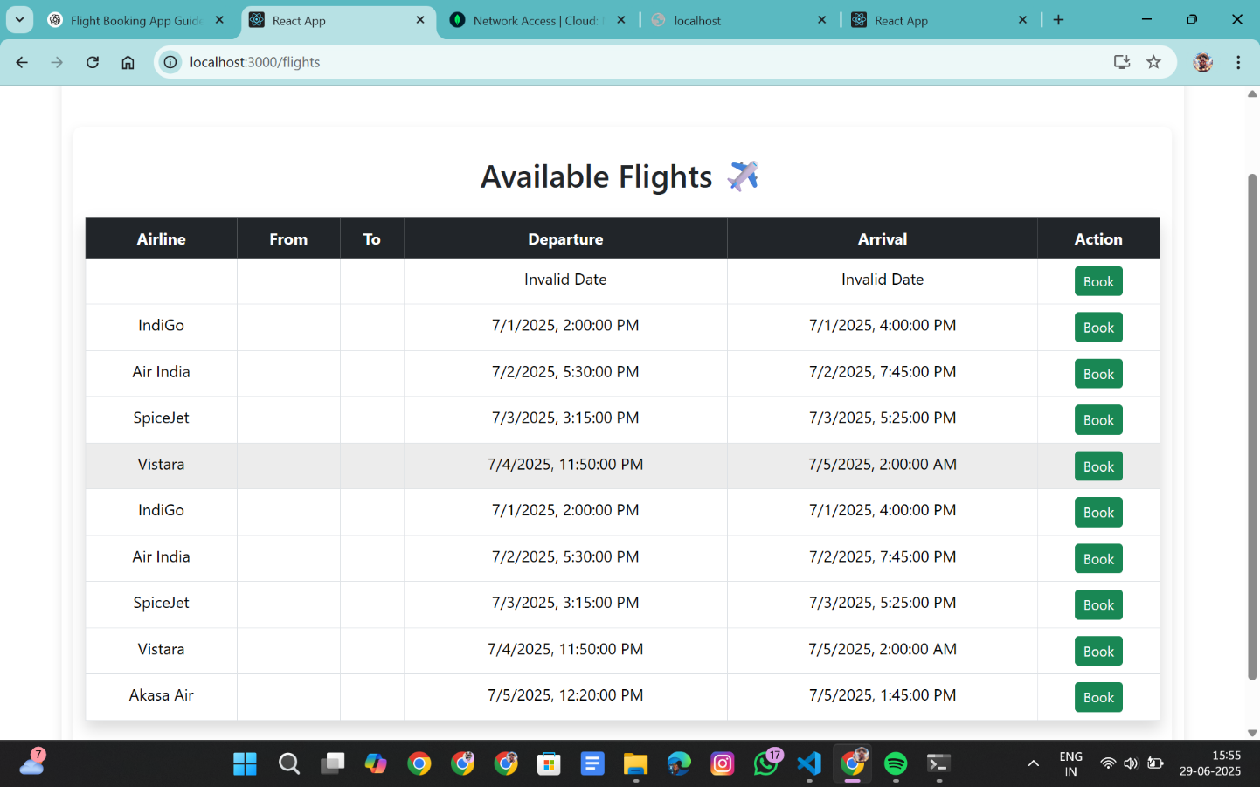

**4. Flight Booking:**

* Users can book flights by entering passenger details.
* Class selection (Economy/Business) dynamically updates price.
* Total price calculation based on passengers and class.

**5. Booking Management:**

* Users can view all their bookings.
* Option to cancel bookings (status changes to "Cancelled").

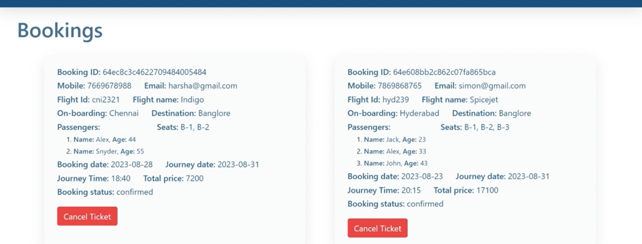

**6. Admin Dashboard:**

* Displays total users, flights, bookings, and revenue.
* Links to manage users and flights.

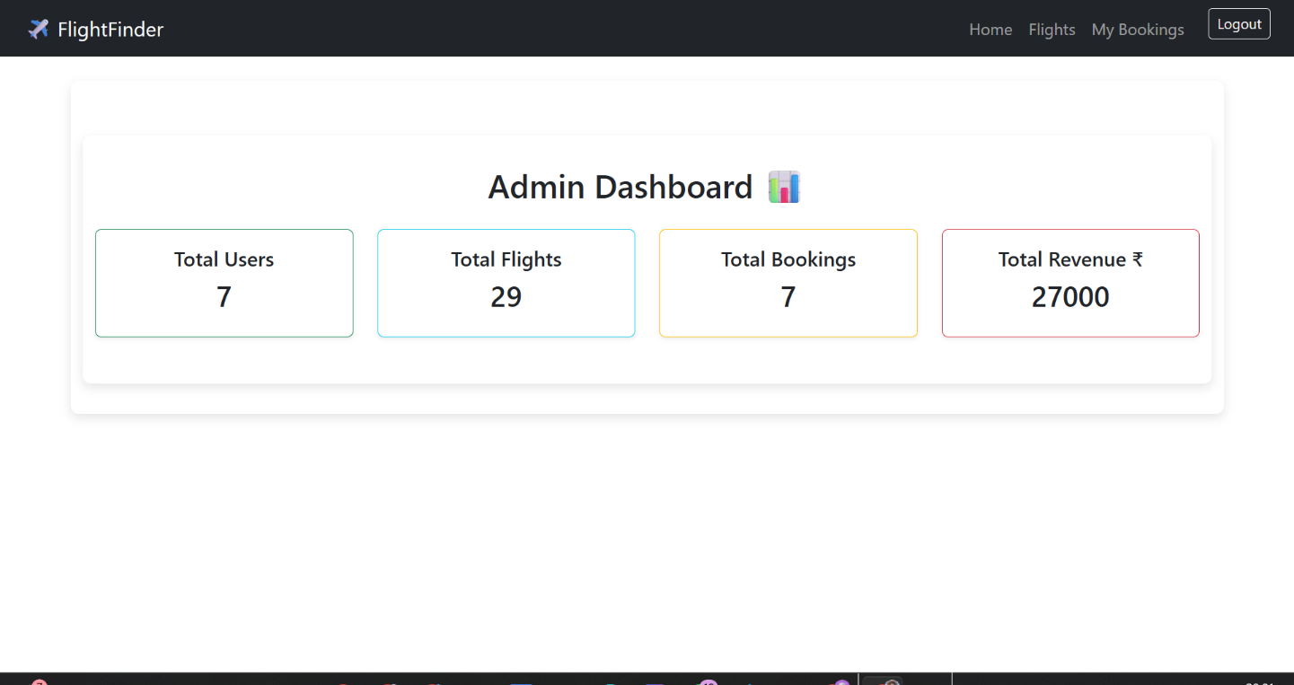

**7. User Approval Panel:**

* Admin can approve or reject operators.
* Operators must be approved before managing flights.

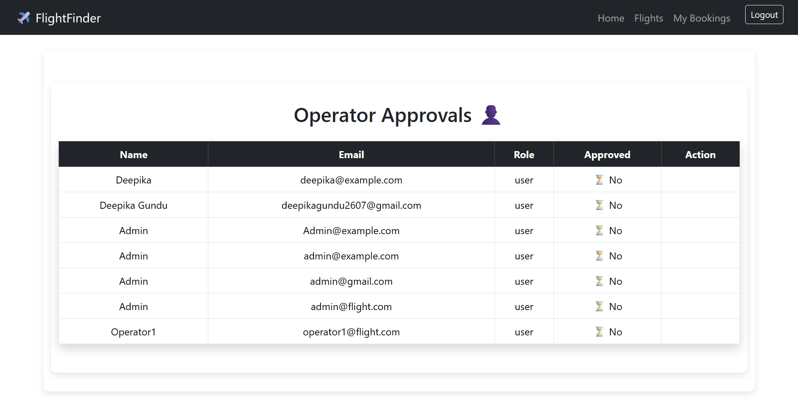

**8. Flight Management:**

* Admins/operators can:
  + Add new flights
  + Edit existing flight details
  + Delete flights

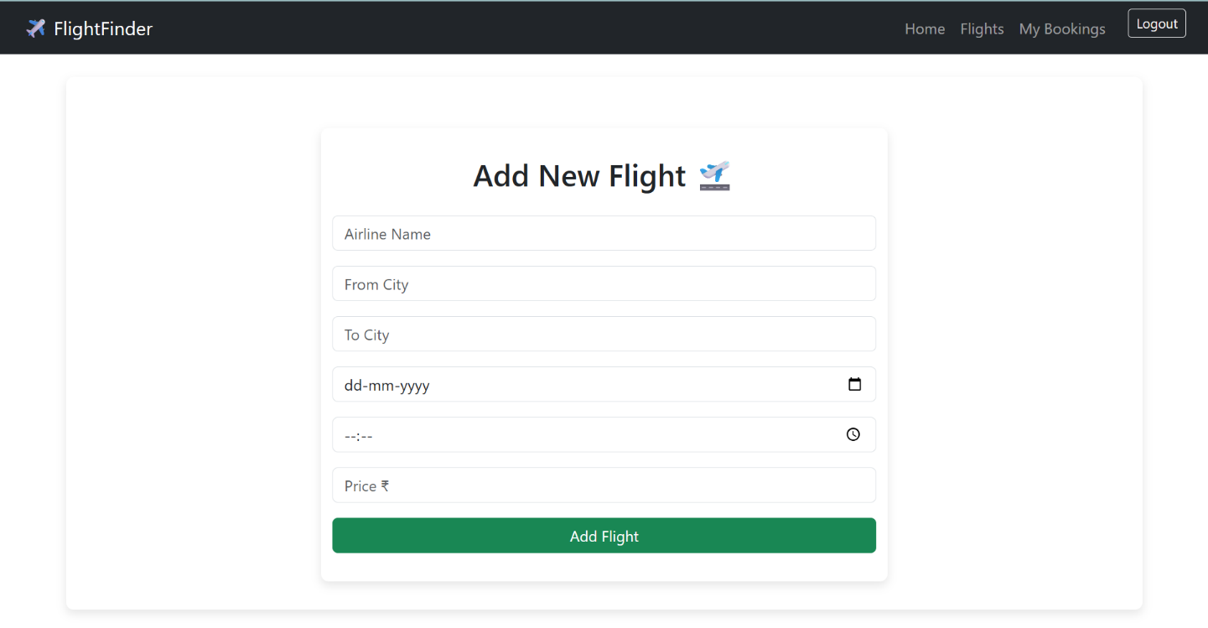

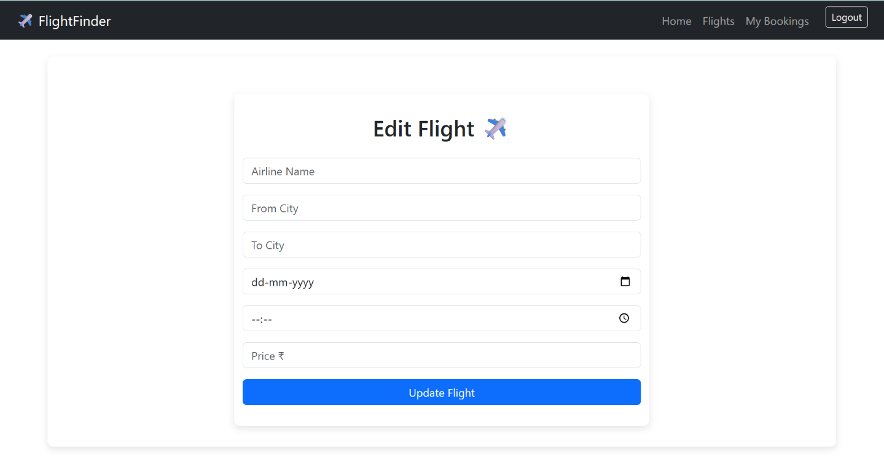

**Conclusion:**

The **Flight Finder** web application successfully demonstrates the power and flexibility of full-stack development using the **MERN stack**. It offers a practical and user-friendly platform for flight search, booking, and management. From dynamic UI components to secure backend routes, the app integrates all essential features needed for a modern travel booking system.

This project not only provides a seamless experience for end users but also showcases role-based access for administrators and operators to manage flights and users. With real-time updates, structured data handling, and intuitive navigation, Flight Finder is an ideal solution for learners, developers, and academic use cases looking to understand real-world application architecture.

Githublink: https://github.com/deepikagundu2622/Smart-bridge.git